Step-by-step guide

1. Install the latest version of Node.JS <https://nodejs.org/en/download/>
2. More info <http://blog.teamtreehouse.com/install-node-js-npm-windows>

Windows environment variables

The SASS project requires a number of node_modules to execute these will be executed locally from the project directory. To execute them locally you will need to add a PATH variable to your user account

1. open Control Panel\System and Security\System, click Advanced system settings
2. 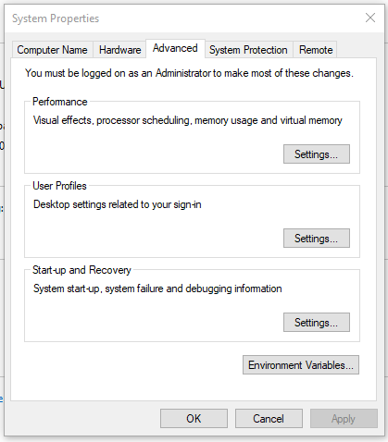click Environment Variables..
3. 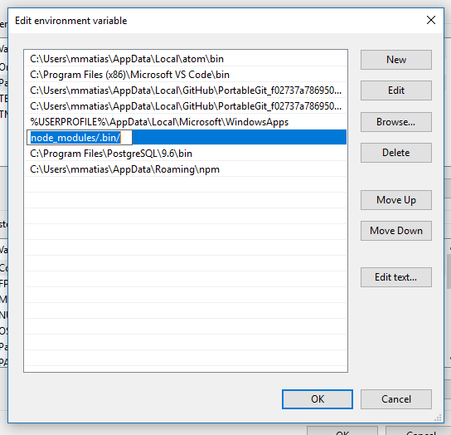Edit Path for you local user
4. Add a new entry "node_modules/.bin/"

Install the node modules

1. open the Repo folder in CMD or PowerShell and at the root dir, run: *npm install*

Compiling the SASS

**To compile the CSS and watch for changes to the /sass folder**

1. Open the Repository location using command line or powershell
2. At the root folder run *gulp*
3. this will compile the recent changes to /css/theme.css then watch the files under the /sass folder, while this task is running, Once you save a .scss file the CSS will recompile

**To compile the CSS without the watch feature**

1. Open the Repository location using comand line or powershell
2. At the root folder run *gulp-theme*

this will compile the recent changes to /css/theme.css